How to Guide
Loading Static Data XML
Files into Siena

Version: | Version 1.0

Issue Date: | 06 January 2011

Review and Approval

Role | Name | Signature | Date
Author | Oliver Eggert |  | 06/01/2011
Reviewer | Dick Buttler |  | 06/01/2011
Authoriser | Purnima Trasi |  | 06/01/2011

Version History

Version | Date | Author | Reason
1.0 | 06/01/2011 | Final

Distribution
For Action | For Information
Project Management

Document Location
N/a
Related Documents
N/a
Definitions of Terms and Abbreviations
Term/Abbreviation | Description

Contents
Contents 3
1 Process Coverage 4
1.1 Instruction Packages 4
1.2 Cross References 4
1.3 XML Formatting 4
1.4 Templates 4
2 Instruction Packages 6

Process Coverage
This guide takes the user through the process of configuring the Siena Static Data Importer through to processing import xml files containing data.

Instruction Packages

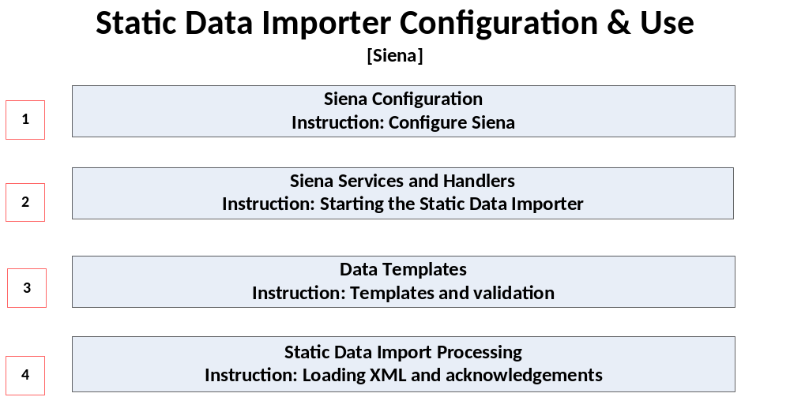

Cross References
- Templates referred to in this document are sample xml formats that can be adapted for purpose.
- To verify import data formats, the Siena Database Manual should be used.

XML Formatting
In order to validate the XML formatting, the file can be opened using standard xml editors; this should reveal xml syntax issues but will not validate values entered as being correct. XML formatting can also be validated against a dataimport.xsd file; this is described further in instruction3.

Templates
Name | Embedded Object | Instruction
Append Services append.txt | 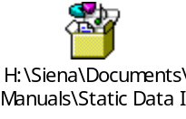
twist_StaticDataImporter.properties
Append externalInterface properties.txt
Standard Templates | 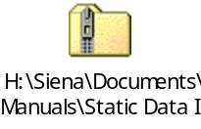
Dataimport.xsd

Instruction Packages

Siena Configuration
1
Instruction: Configure Siena.

- Purpose: To define the system configuration needed to run the static data importer where such configuration does not exist already. Note that this instruction needs to be implemented by a technician. The following are required:
  - Configuration of the Static Data Importer in service.properties
  - twist_DataImporter.properties
  - externalInterface.properties
  - genericTwistPanel.properties
  - Directory locations for the data_importer_in and data_importer_out folders

This configuration should be replicated for each Siena server.

- Services.properties
  - Open the “Append Services properties.txt” file and append to the services.properties file in the std/systems/..config directory.
  - Update the service number in the appended part to the next available service number.
  - Obtain an available port number from your technical resource department and replace the value of 4045 with the new port number. The port number is found in the row beginning “service15.args…”.
  - Save the file.

- Twist_DataImporter.properties
  - Copy the twist_StaticDataImporter.properties file into the std/systems/..config directory.

- externalInterface.properties
  - Open the “Append externalInterface properties.txt” file and append to the externalInterface .properties file in the std/systems/..config directory.
  - Save the file.

- genericTwistPanel.properties
  - Insert “StaticDataImporter” into the remote service list e.g. remoteServiceList=RateExporter,DealExporter,LimitImporter,DealImporter,RMDS,LimitImporter,Deal,RMDS,RateManager,RateImporter,StaticDataImporter,remoteServiceList.DealingInterface=360T,FXall,FIXEngine,Bloomberg
  - Save the file.

- Data input and output locations
  - Create two folders in the std/systems/..data directory. These should be called:-
    - data_import_out
    - data_import_in

To verify that the configuration is correct, the service and handler need to be started - see the next section for details.

Siena Services and Handlers
2
Instruction: Starting the Static Data Importer

- Purpose: To detail how the Static Data Importer service and Static Data Import Handler are started from the Siena Tool bar.
- Starting the Static Data Importer service
Select the System Manager from the Siena Tool bar [See image below]
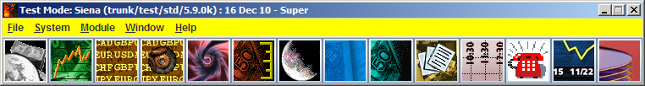
Go the row where the Static Data Importer is defined and select the server on which the service is going to be run. Then hit the Start button to initiate the service. Only once the process has started its status changes to “Running”. [See images below for further guidance]
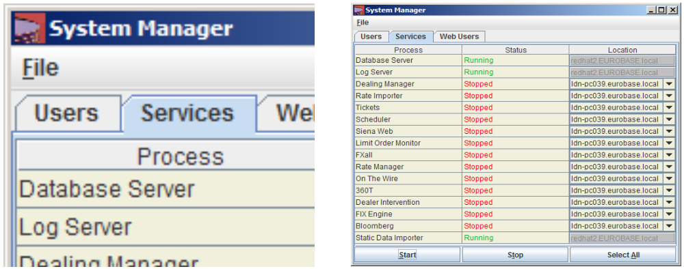
Note if the System Manager appears totally blank, it is very likely that you have made a configuration error in the services.properties file. If the service goes to “Failed” status, you need to check for error log messages in the following log files StaticDataImporter.log, SienaClient.log and dbServer.log (You may be asked by Eurobase Technical support to provide others log files too).
- Starting the Static Data Importer Handler
Once the Static Data Importer is running, select the Services Manager menu item from the Siena Tool bar as indicated in the image below.
Select the TwistContainer tab, and then highlight the row with the label StaticDataImportHandler. Now click on the Start Button to start the handler. Once the handler status is set to “Running”, static data importing can commence.
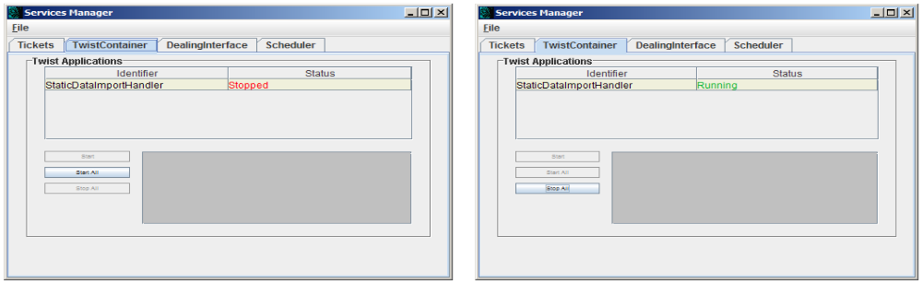

Data Templates
3
Instruction: Templates and validation

- Purpose: To extract templates and amend them to define data to be imported.
  - Copy Required Template to an interim folder
  - Make changes & Save File
  - Validation against the dataimport.xsd (optional)
- Copy Required Template to a temporary folder
From the templates select the template from the Standard Templates Zip (Compressed Folder). It is strongly recommended that you copy template XML to an interim temp folder before starting to edit it.
- Make changes & Save File
The template XML is best opened using a standard XML editor to highlight syntax errors. Defining values of fields within the XML requires knowledge of XML. Corresponding field attributes/parameters for each Siena Table are provided in the Siena Database Manual. Once data has been defined in the XML, the file must be saved.
- Validation against the dataimport.xsd (Optional)
If the XML editor being used is supplied with an XSD validation utility, any defined XML can be validated against the dataimport.xsd. Note that the attribute fields are not validated by the XSD; they are validated when the record is processed by the importer itself.

Static Data Import Templates available [By Static Data Area]
Table (Template Folder Name) | Primary Functional Usage | Take On & Maintenance
Agreement Dealing Interface | Portal Maintenance | Take On & Maintenance
Agreements | Portal Maintenance | Take On & Maintenance
Amount Band Id | Portal Maintenance | Take On & Maintenance
Amount Bands | Portal Maintenance | Take On & Maintenance
Centre | Firm & Counterparty | Take On & Maintenance
Channel | Portal Maintenance | Take On & Maintenance
Channel Margins | Portal Maintenance | Take On & Maintenance
Counterparty | Firm & Counterparty | Take On & Maintenance
Counterparty + import Id + Firms | Firm & Counterparty | Take On only
Country | General Static Data | Take On & Maintenance
Currency | General Static Data | Take On & Maintenance
Currency Pairs | General Static Data | Take On & Maintenance
Currency Pair Rate | General Static Data | Take On & Maintenance
Dealing Interface | Portal Maintenance | Take On & Maintenance
Firm | Firm & Counterparty | Take On & Maintenance
Mandated User | General Static Data | Take On & Maintenance
Nostro | Front Office | Take On & Maintenance
Nostro Agent | Front Office | Take On & Maintenance
SSI (Full) | Front Office | Take On & Maintenance
Trading Group | Portal Maintenance | Take On & Maintenance
Trading Group Link | Portal Maintenance | Take On & Maintenance

Each Static data area has templates for INSERT, UPDATE & DELETE transactions. Each folder also includes a general dataimport.xsd for validating the XML.

Static Data Import Processing
4
Instruction: Loading XML and acknowledgements

- Purpose: To process XML definitions through the Static data Importer and verify results through logs. There are three steps to this process:-
  - Submitting the Import Data File
  - Auto acknowledging the import
  - Checking the logs for failed imports
- Submitting the Import Data File
Once data has been defined in XML, you should copy and paste the file (Not cut and paste because you may need to repeat the import after having corrected the XML) to the “data_import_in” folder defined in package 1 step 6. Provided that both the Static Data service and handler are running, Siena will pick up the file and will attempt apply the change to the Siena database. The file is deleted after it has been processed.

- Auto acknowledging the import
If the data import has been processed successfully, the system will generate an “ACK” (Acknowledgment) XML message. If the data import fails the system will generate a “NAK” XML message. These messages are generated in the “data_import_out” folder as defined in package 1 step 6.

- Checking the logs for failed imports
To establish the reason for a NAK transaction, further detail will be supplied in one of three areas:-
  - The Event log on the Siena Tool bar
  - In the NAK XML message itself
  - In the StaticDataImporter.log, located in the std/systems/..logs directory.

